**Day 4**

**1 less Data**

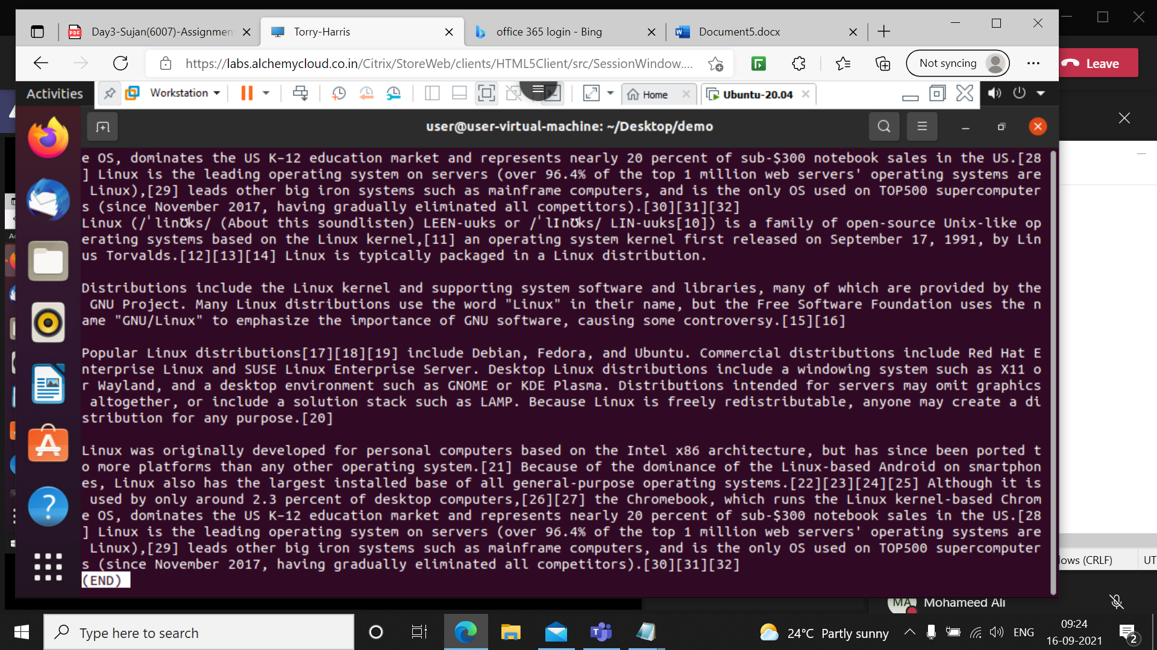Less command is a Linux utility that can be used to read the contents of a text file one page(one screen) at a time. It has faster access because if file is large it doesn’t access the complete file, but accesses it page by page.

**2 less -p 'Linux' Data**

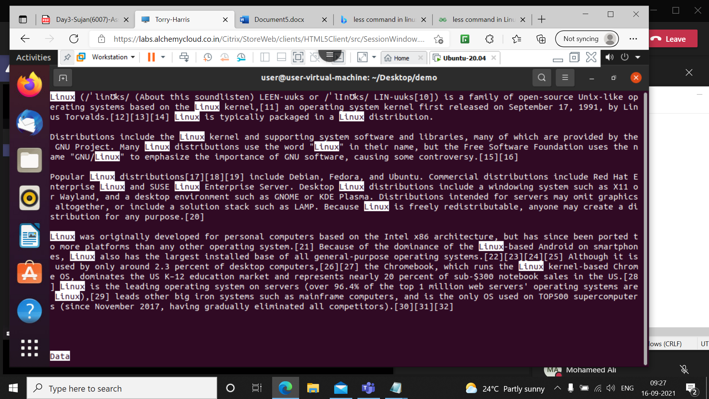

The above command tells less to start at first occurrence of pattern “Linux” in the file.

**3 less -N 'Linux' Data**

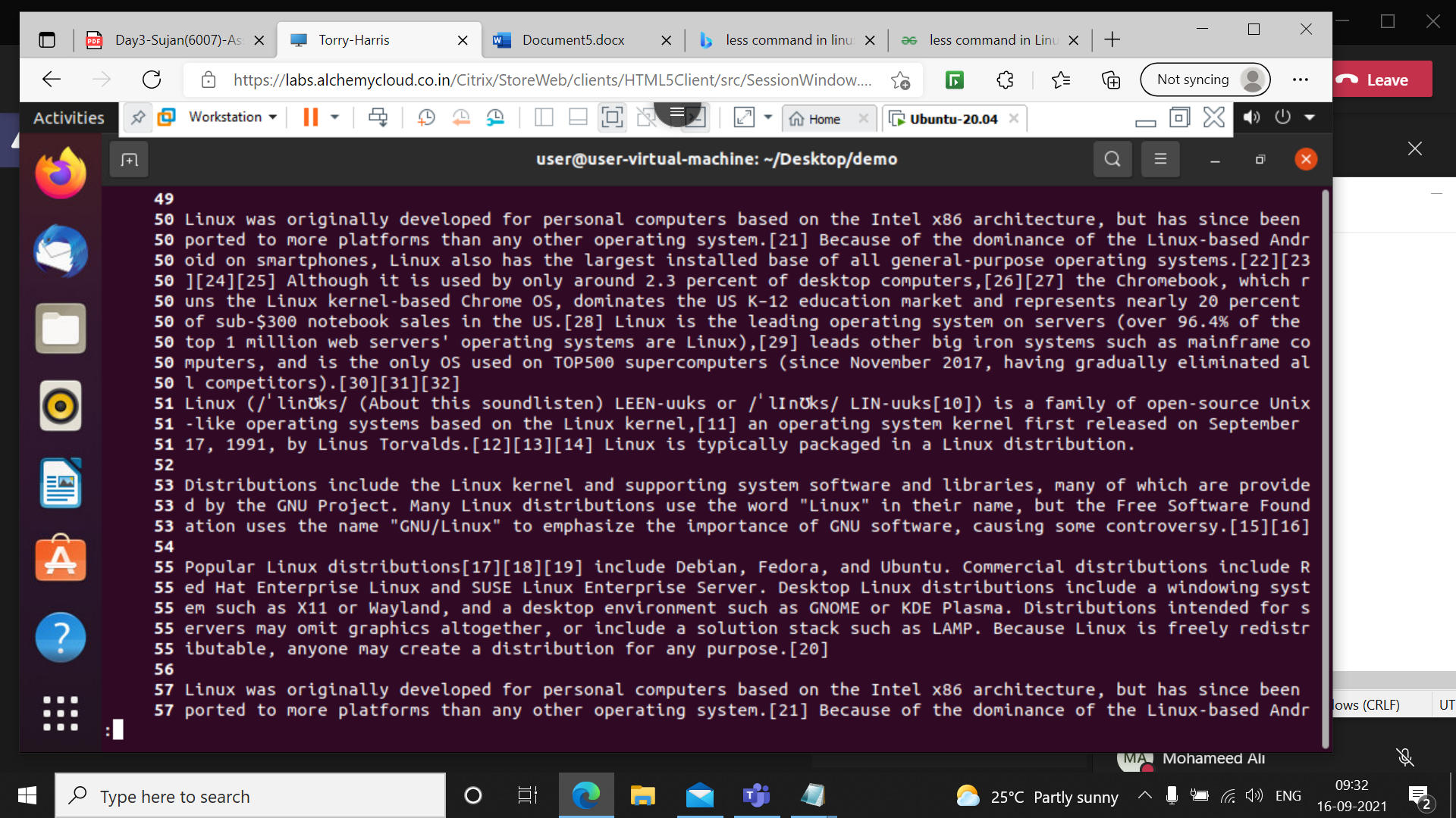

It will show output along with line numbers

**4 sudo apt-get install vim**

This command is used to install the vim in linux

**5 which vim**

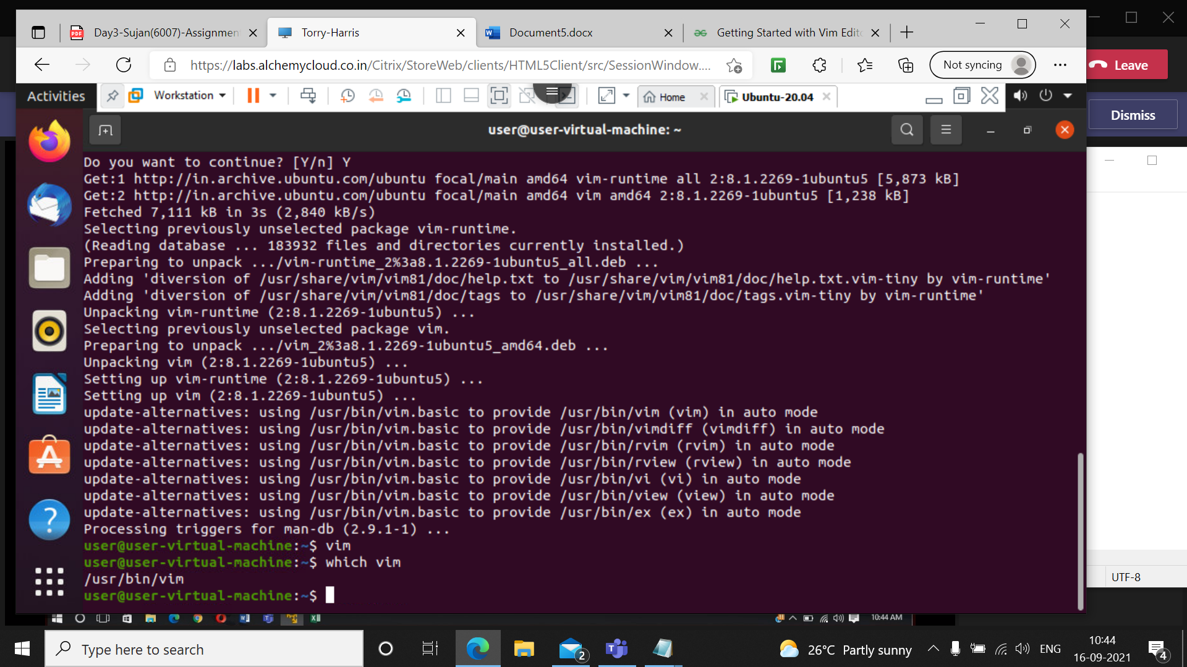

This command is used to check in which directory installed vim is saved

**6 vim**

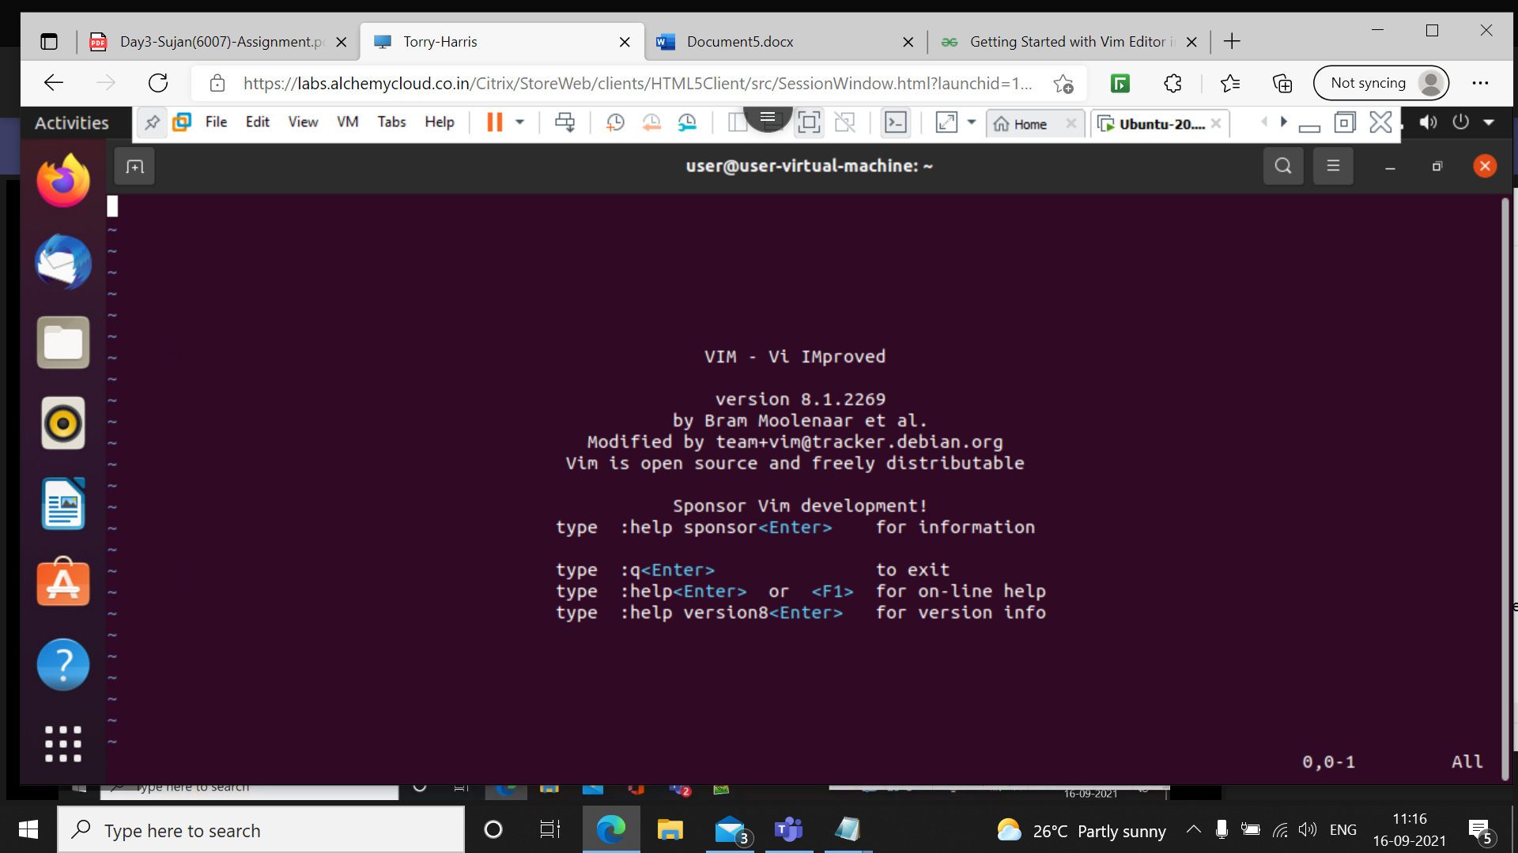

This command will display the installed vim window

**7 I**

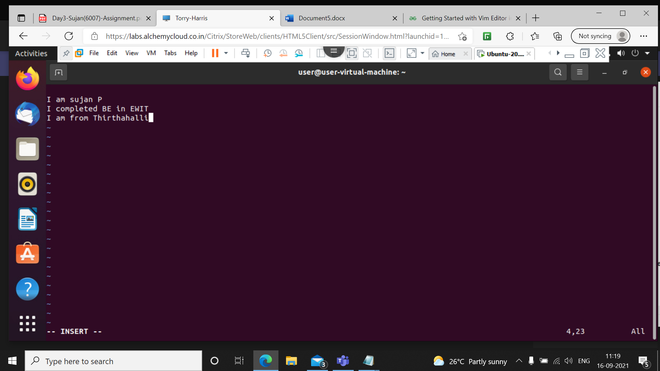

I command is used to insert the data in vim editor

**8 :w sujanp**

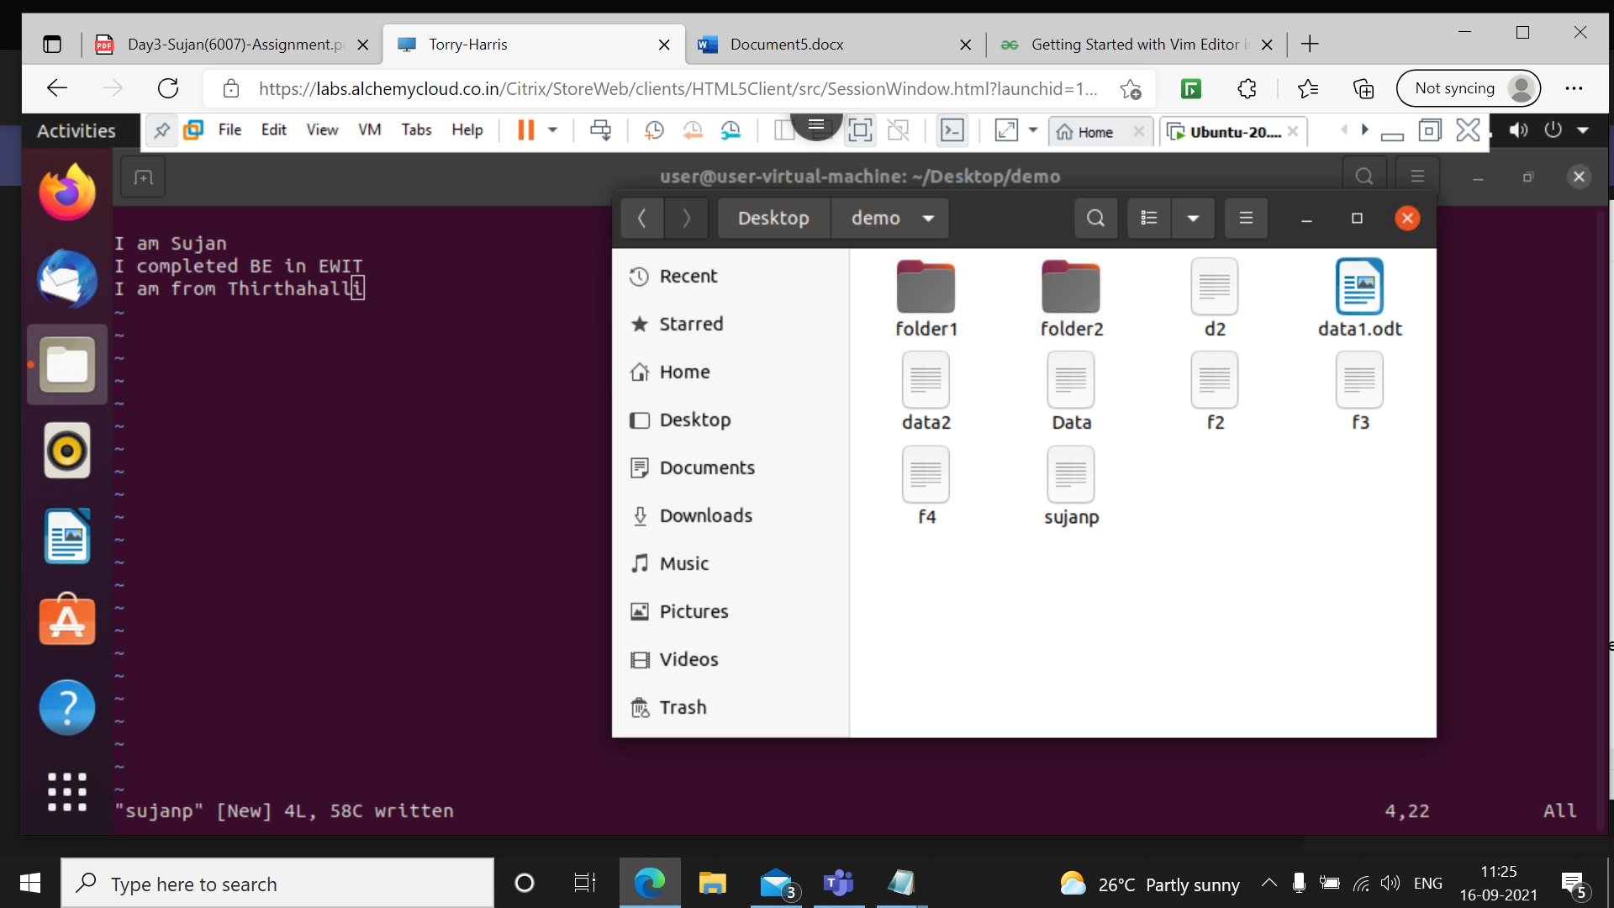

This command is used to save the file in vim editor

**9 :q!**

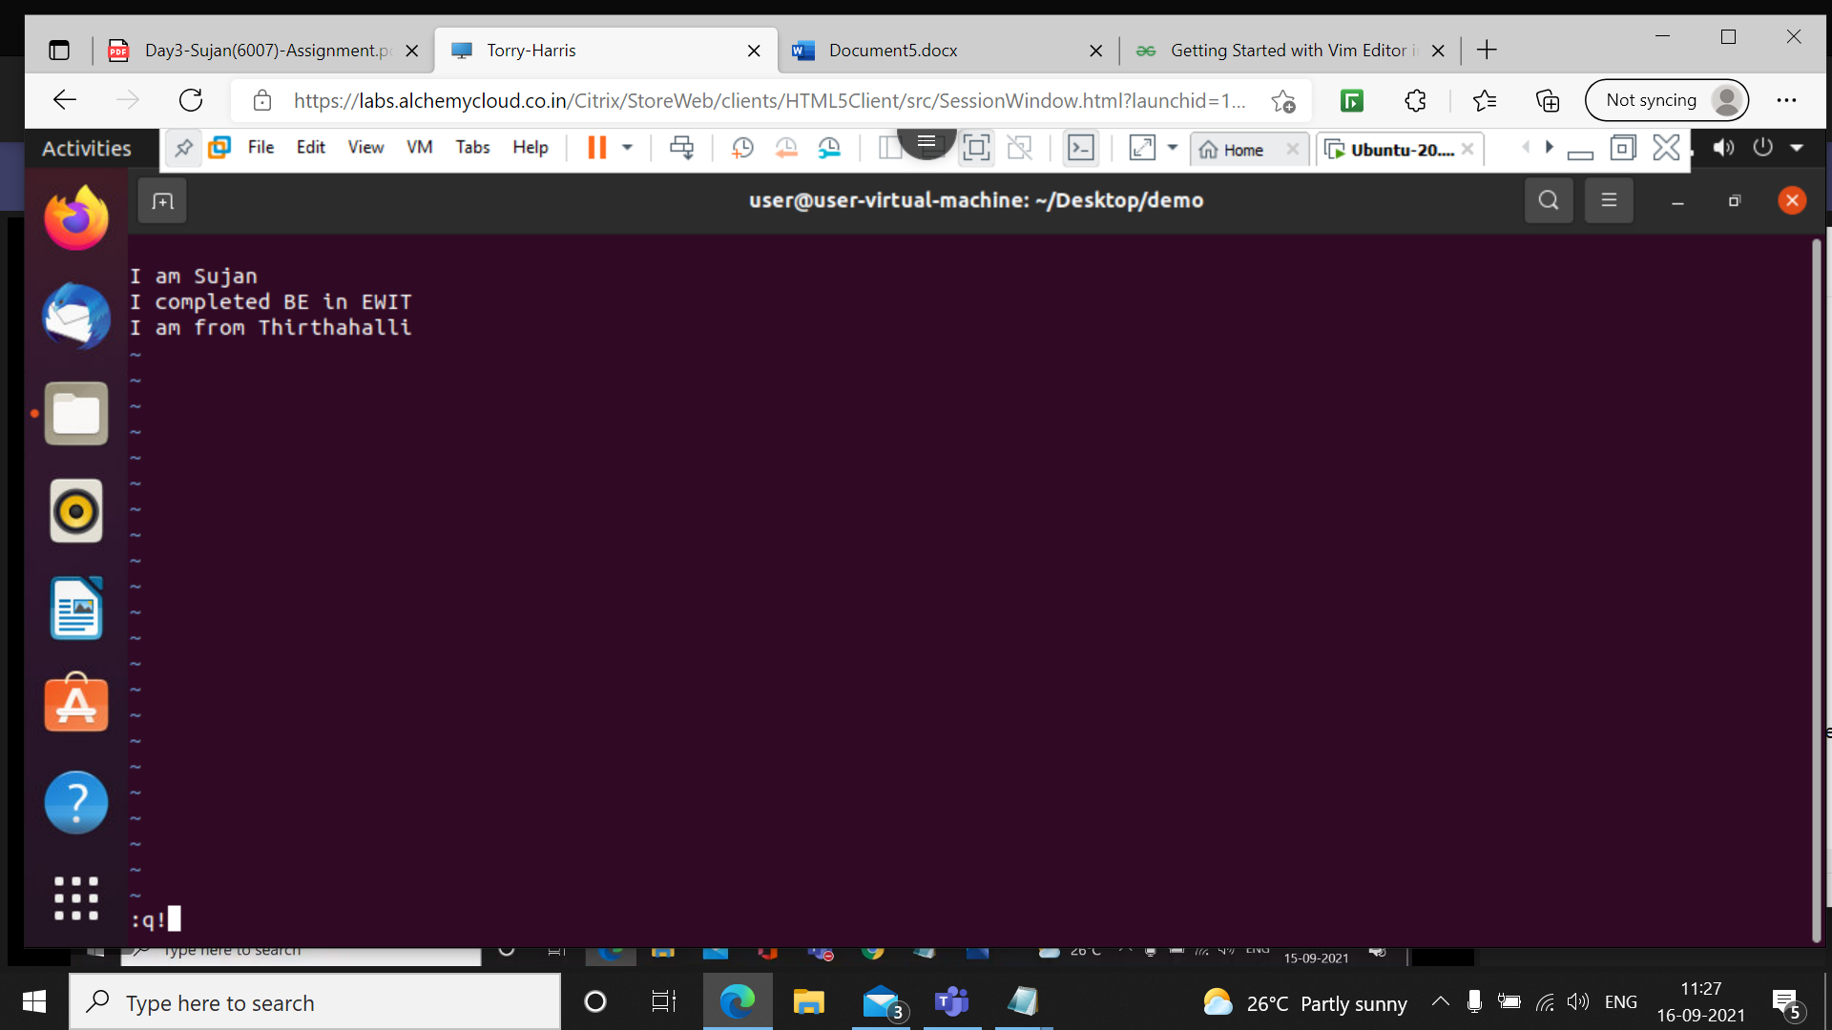

This command is used to quit the vim window

**10 vim sujanp**

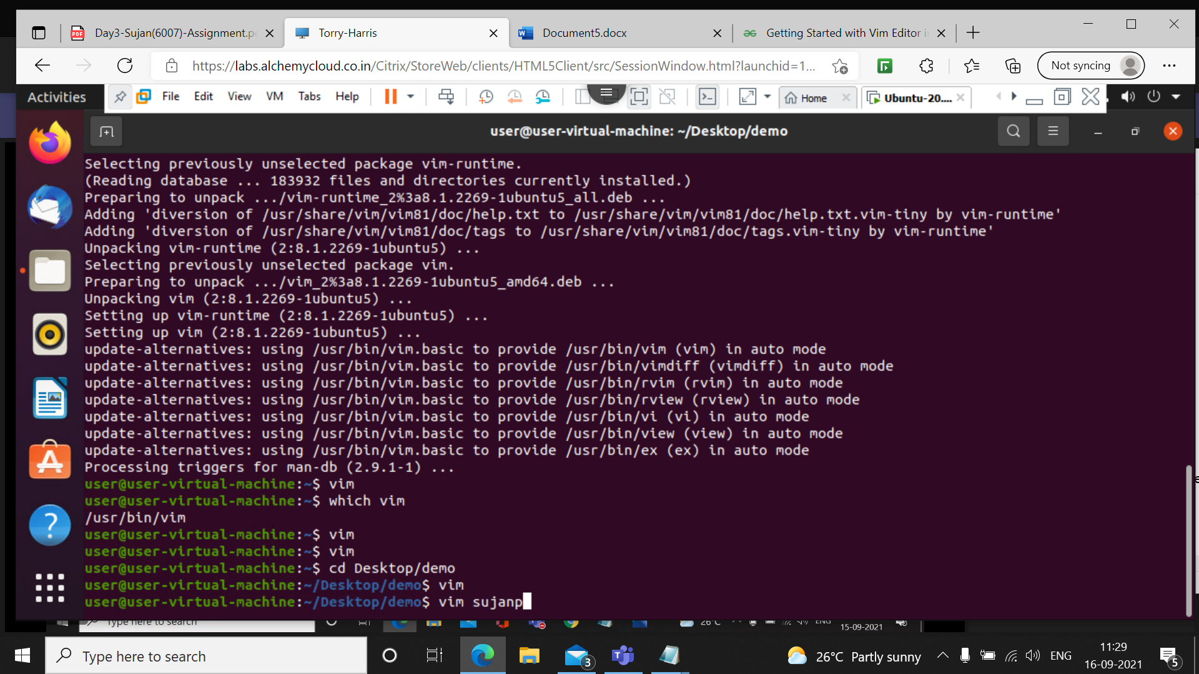

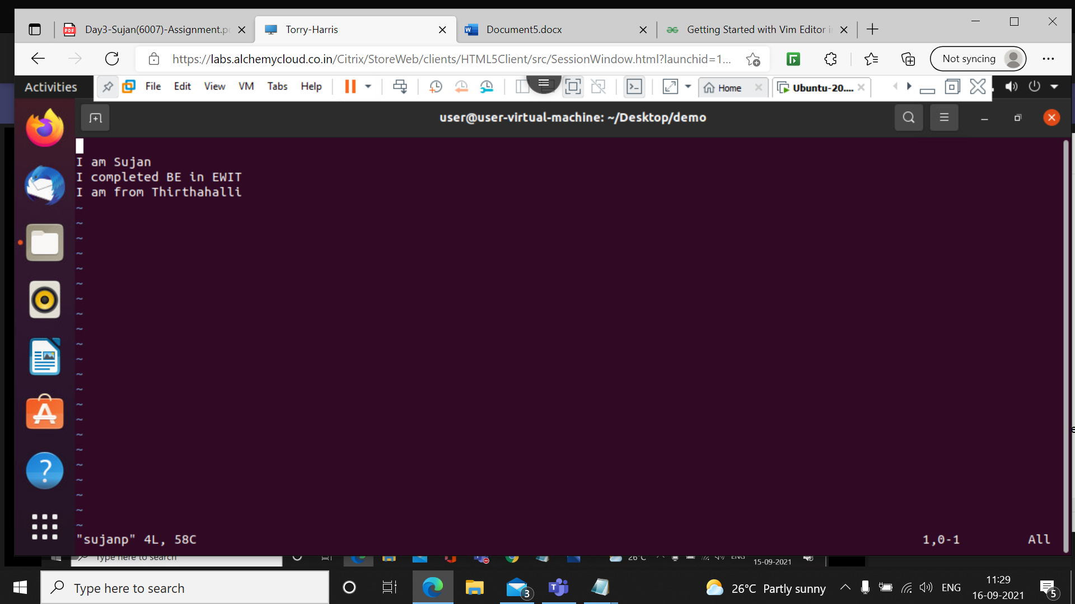

This command is used to open the saved file

d-delete line by line

x-delete word by word

u-undo

**11 vim sujanp**

**:r f2**

**:w**

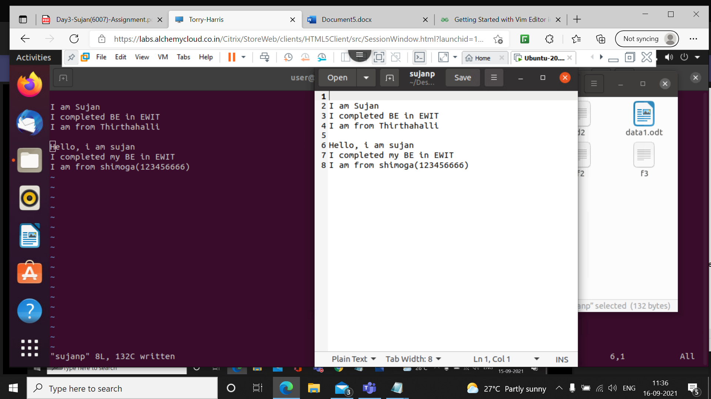

This command is used to copy the data of one file into another file

:w is used to save the file

**12 find Data**

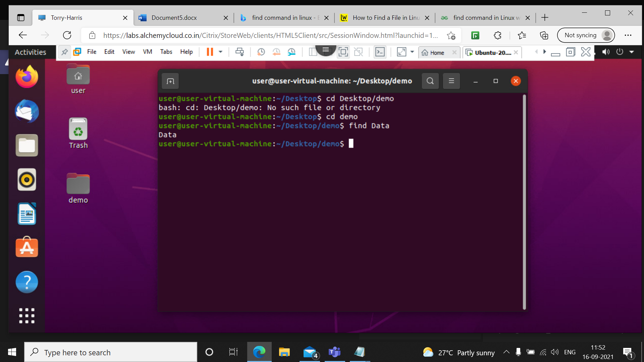

The **find** command is a command line utility for walking a file hierarchy. It can be used to find files and directories and perform subsequent operations on them. It supports searching by file, folder, name, creation date, modification date, owner and permissions.

**13 find . Data**

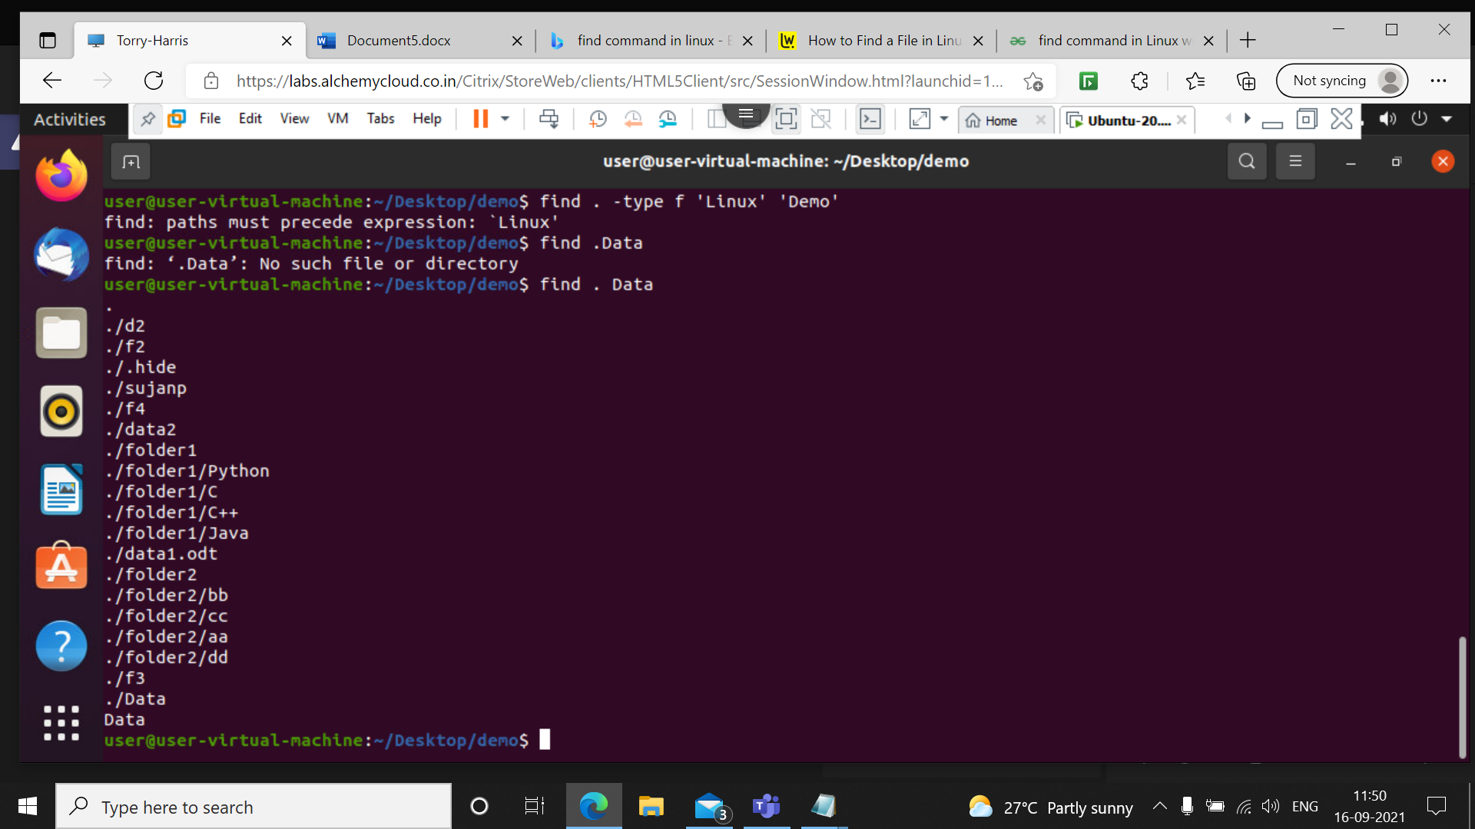If we want to search the folder currently in use, we can use the following command

**14 head d1**

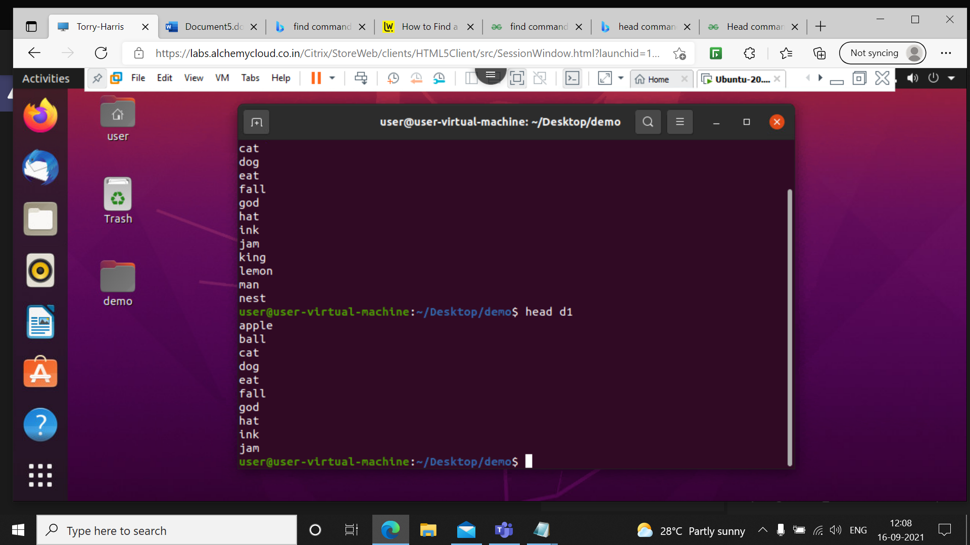

The head command, as the name implies, print the top N number of data of the given input. By default, it prints the first 10 lines of the specified files. If more than one file name is provided then data from each file is preceded by its file name.

**15 head –n 5 d1**

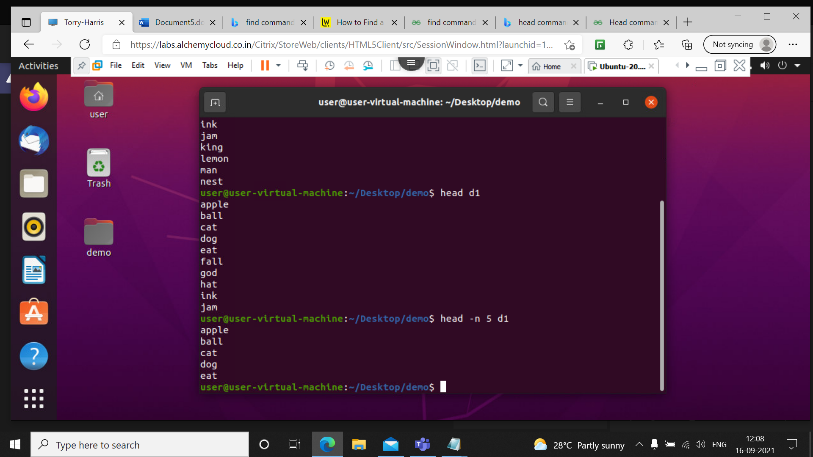

Prints the first ‘5’ lines instead of first 10 lines.

**16 head –c 6 d1**

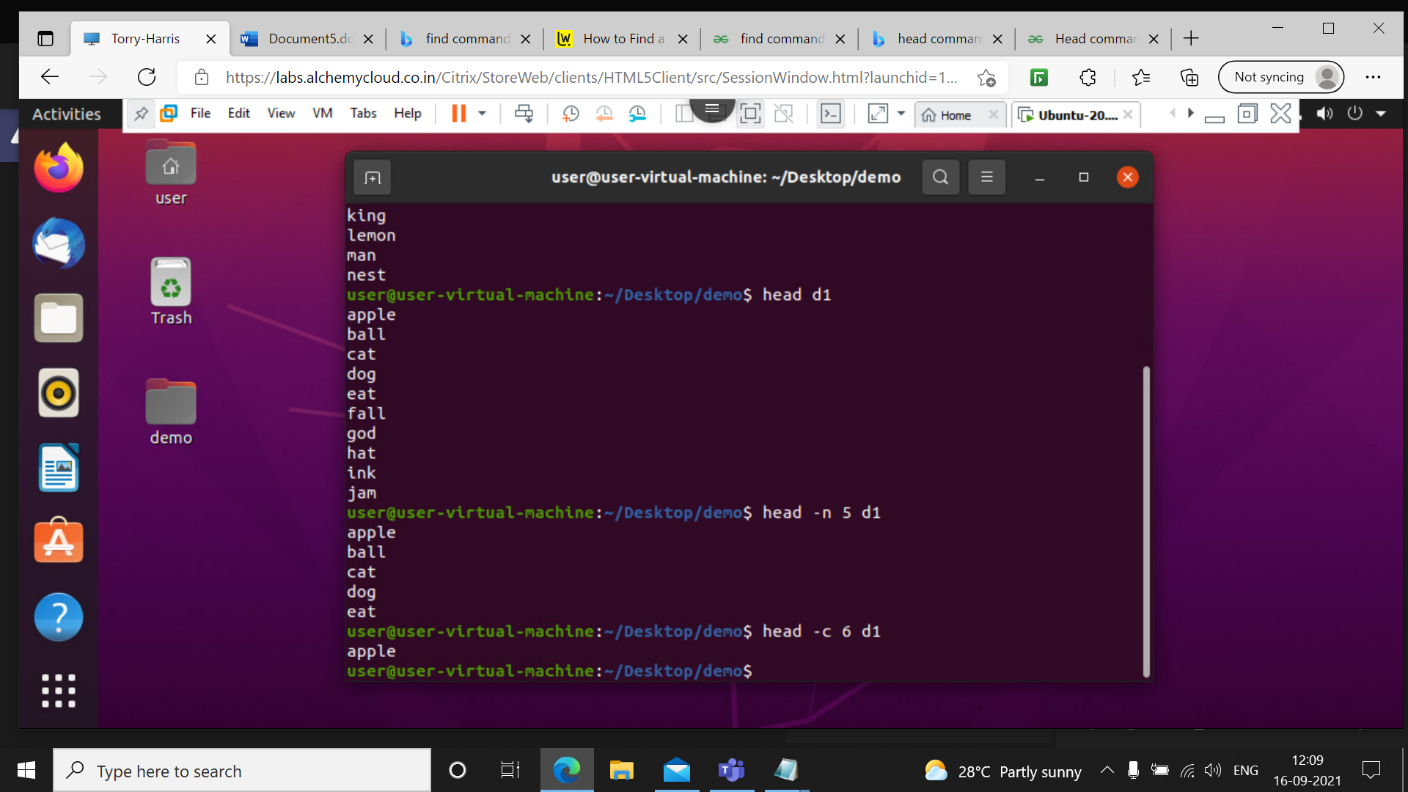

Prints the first ‘num’ bytes from the file specified. Newline count as a single character, so if head prints out a newline, it will count it as a byte. **num** is mandatory to be specified in command otherwise displays an error.

**17 head –q d1 f4**

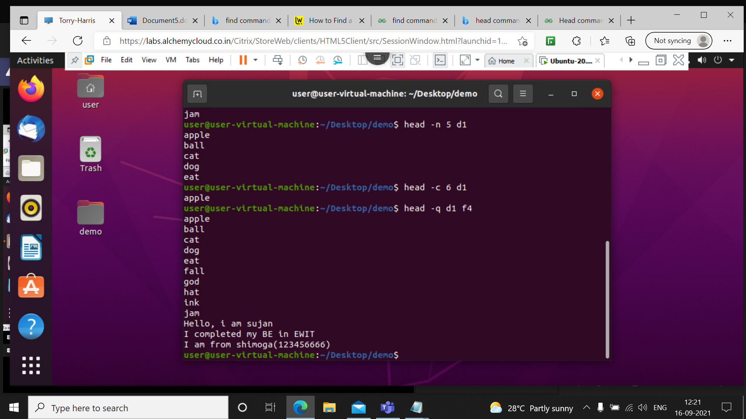

It is used if more than 1 file is given. Because of this command, data from each file is not precedes by its file name.

**18 head –v d1**

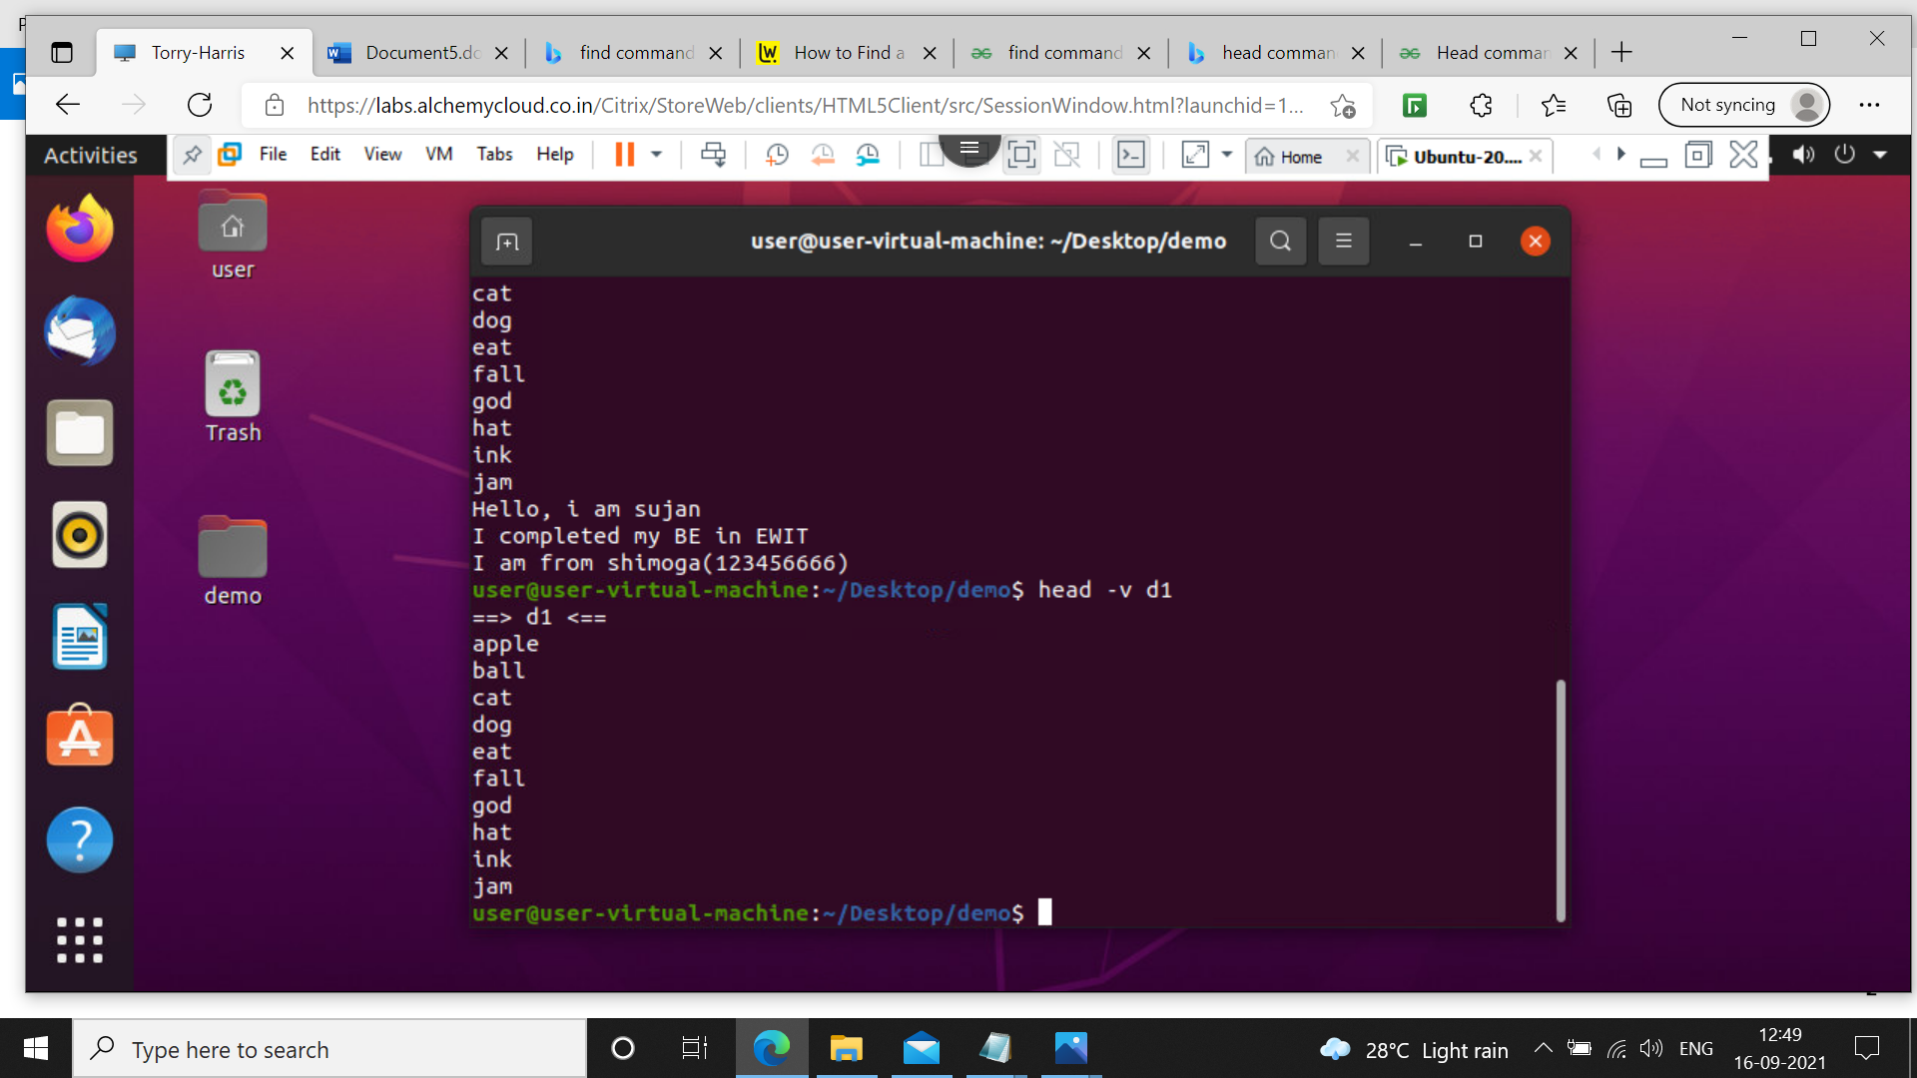

By using this option, data from the specified file is always preceded by its file name.

**19 tail d1**

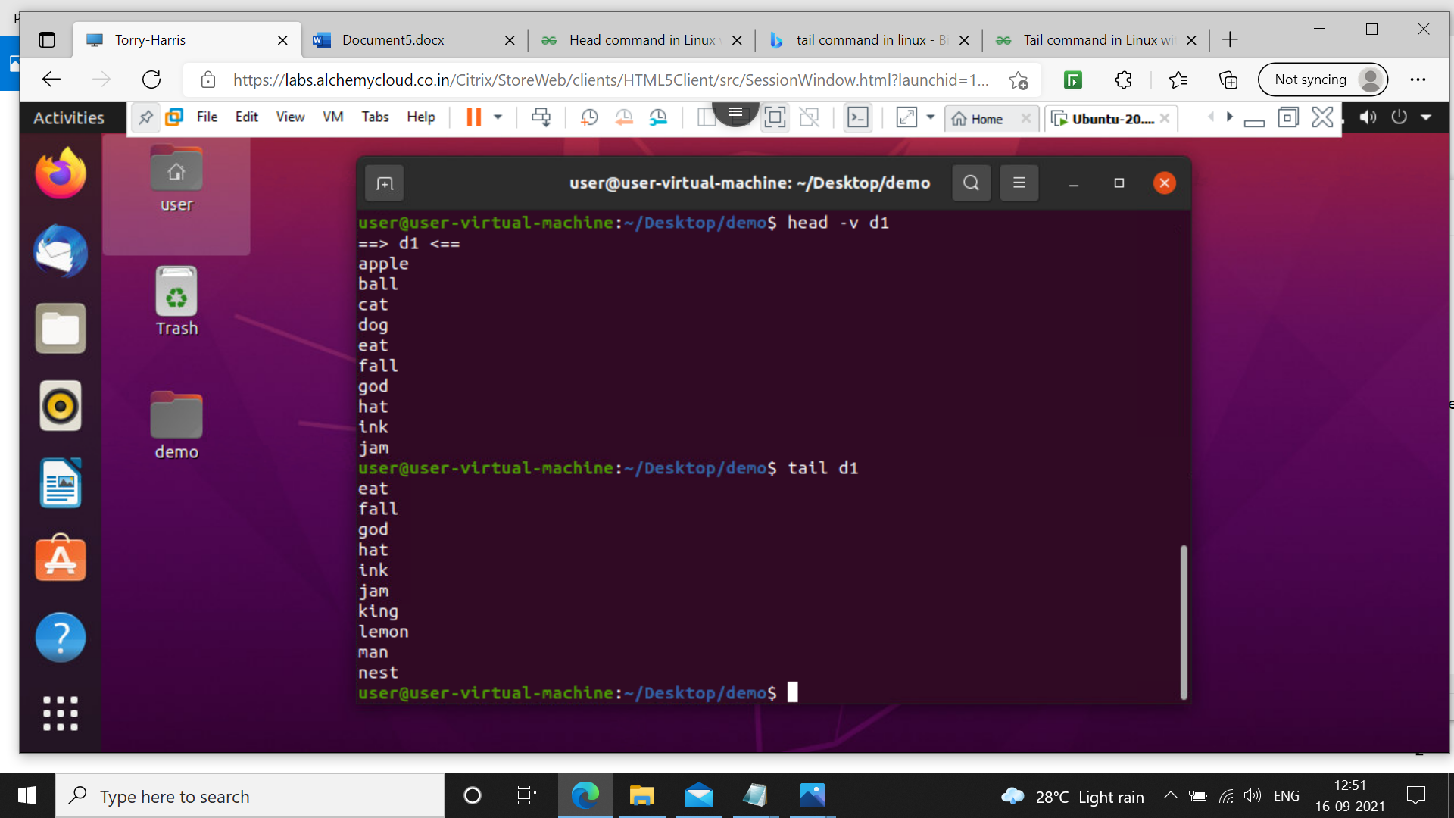

It is the complementary of [head](https://www.geeksforgeeks.org/head-command-linux-examples/) command.The tail command, as the name implies, print the last N number of data of the given input. By default it prints the last 10 lines of the specified files. If more than one file name is provided then data from each file is precedes by its file name.

**20 tail –n 4 d1**

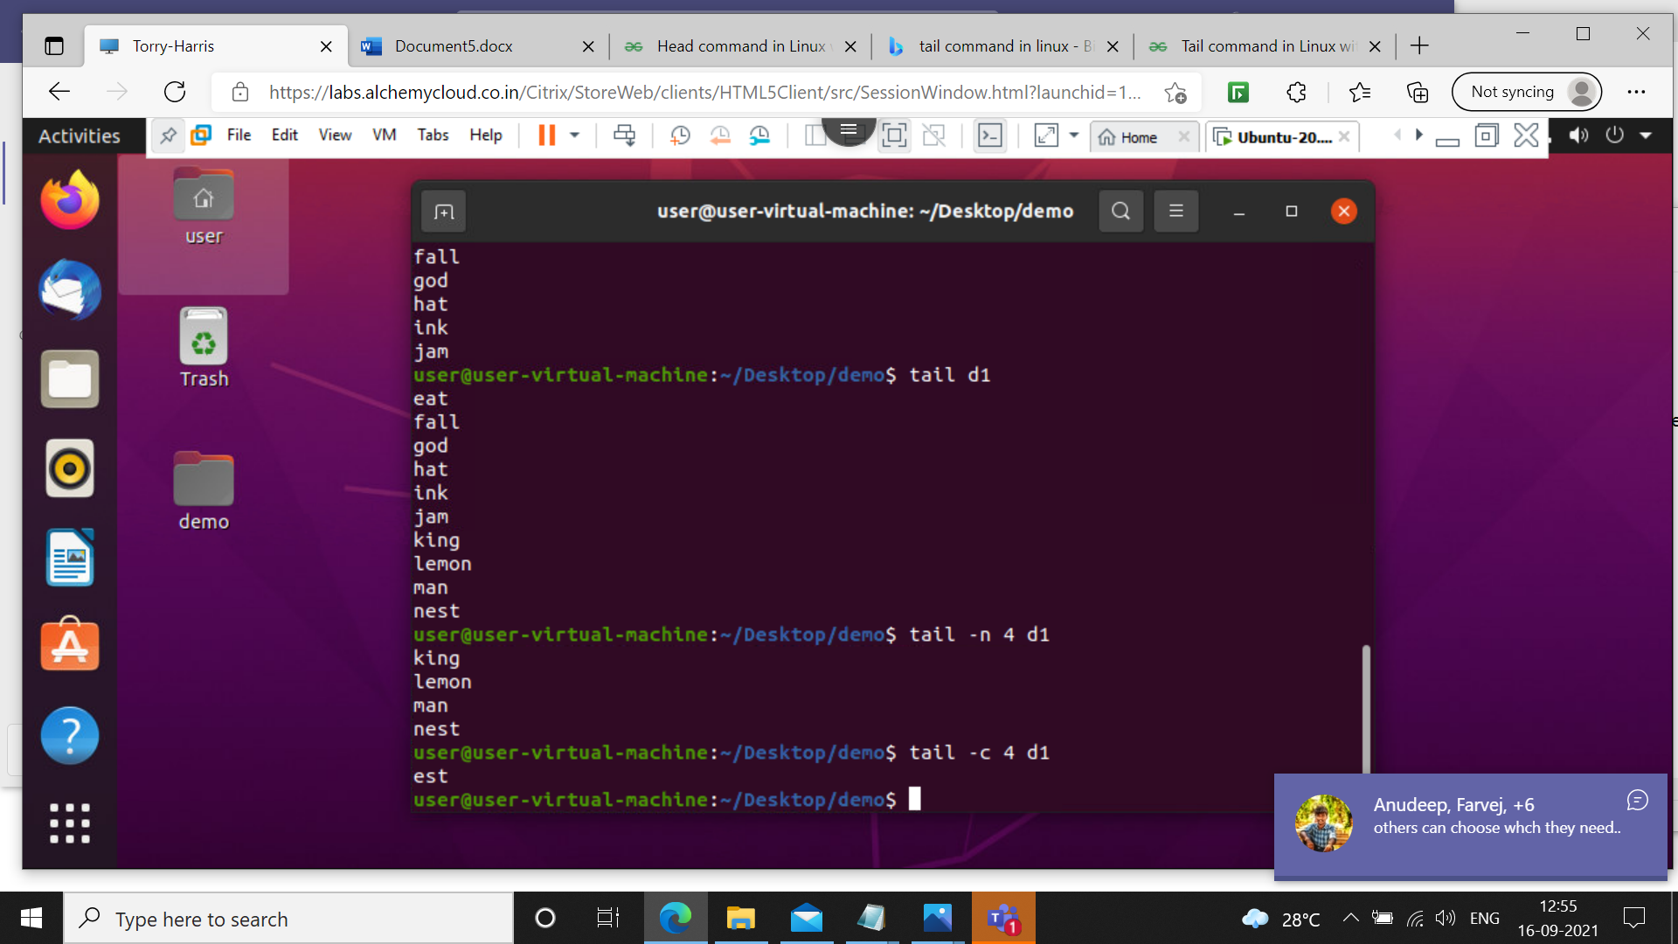

Prints the last ‘num’ lines instead of last 10 lines. **num** is mandatory to be specified in command otherwise it displays an error.

**21 tail -c 4 d1**

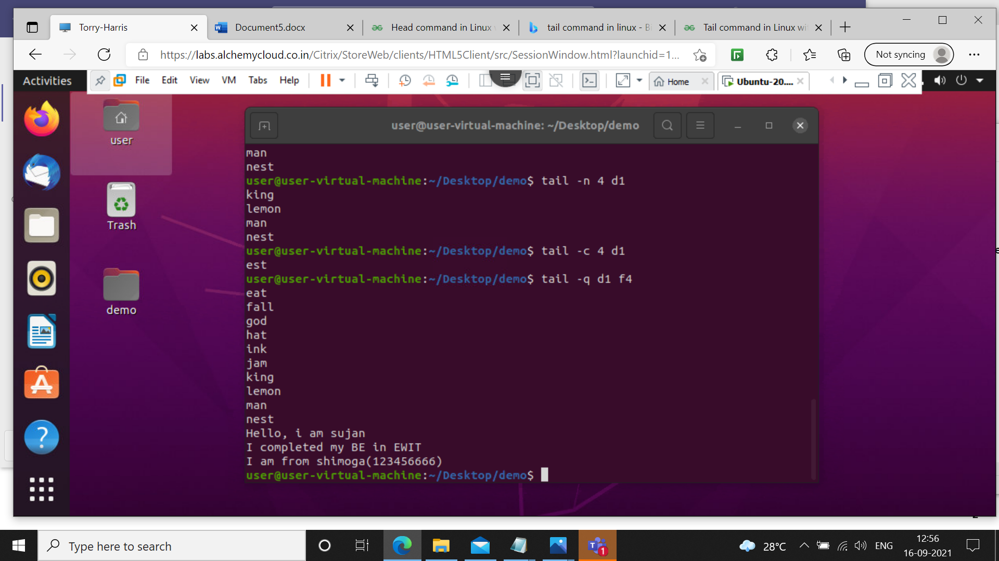

Prints the last ‘num’ bytes from the file specified. Newline count as a single character, so if tail prints out a newline, it will count it as a byte. In this option it is mandatory to write **-c** followed by positive or negative **num** depends upon the requirement.

**22 tail –q d1 f4**



It is used if more than 1 file is given. Because of this command, data from each file is not precedes by its file name.

**23 tail –v d1**

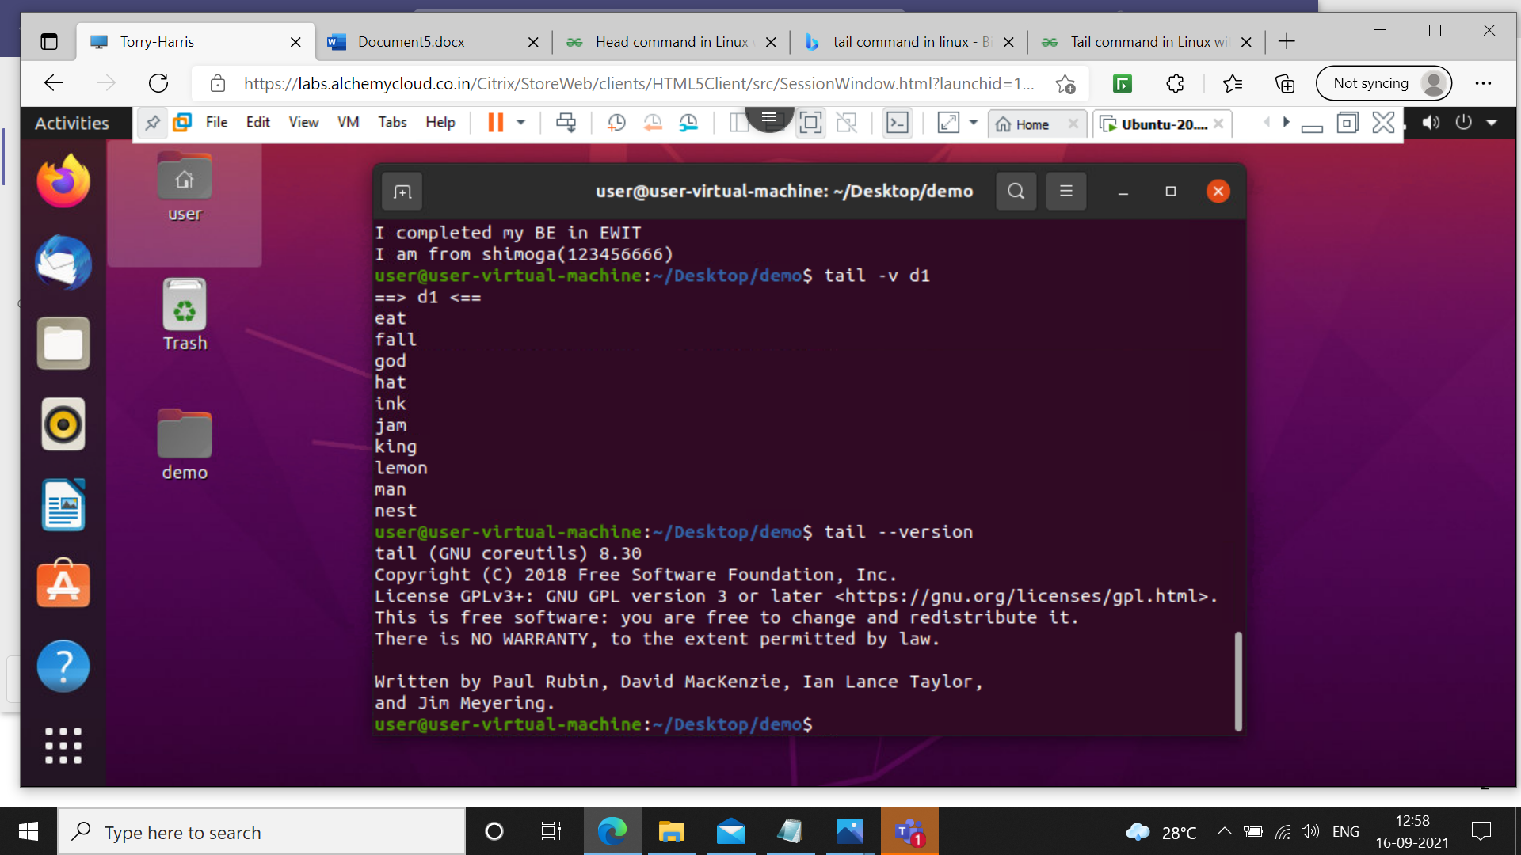

By using this option, data from the specified file is always preceded by its file name.

**24 tail –n 5 d1 | sort**

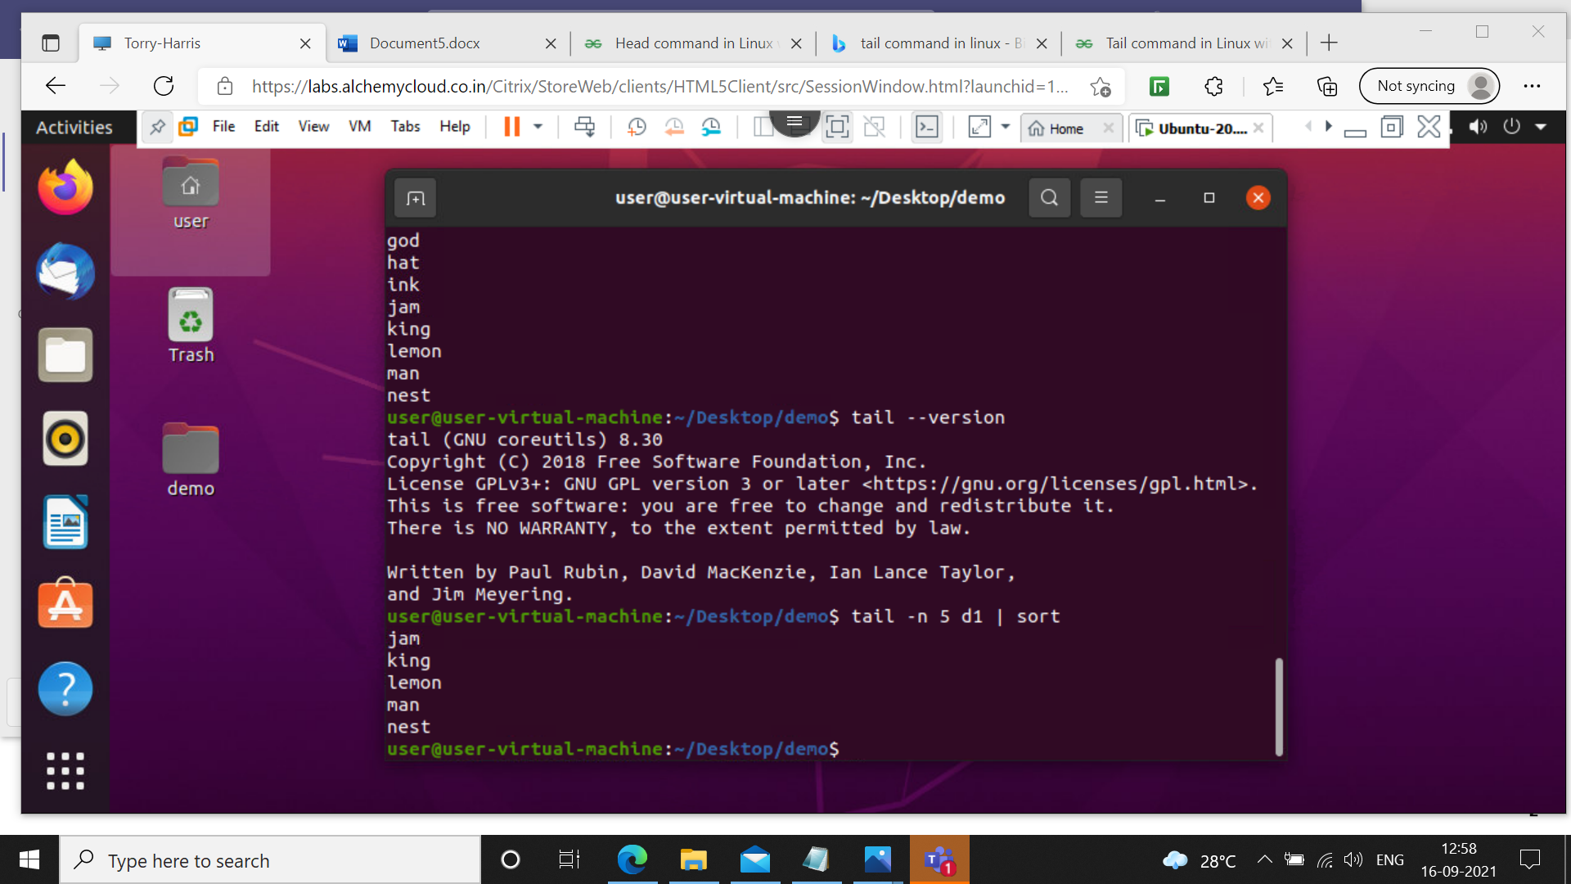

This command will print last 5 lines with alphabetically sorted those lines

**25 tail --version**



This option is used to display the version of tail which is currently running on your system.

**26 head –n 5 d1 | tail –n 1**

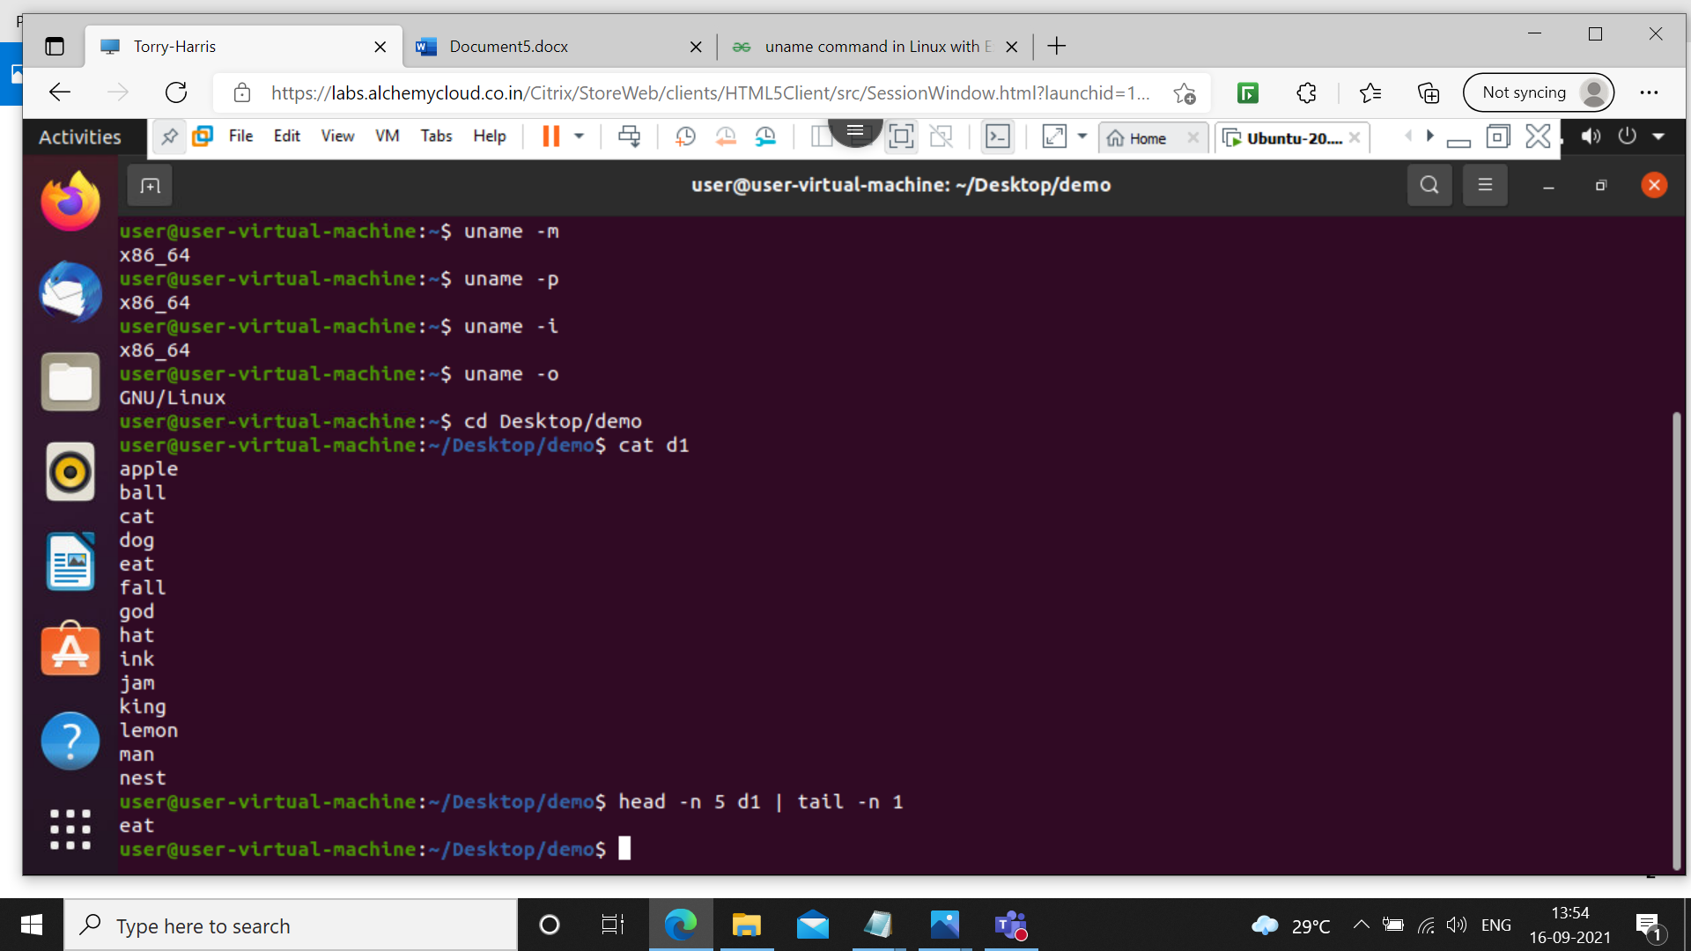

This command will print only the 5th line

**27 ls | head –n 4**

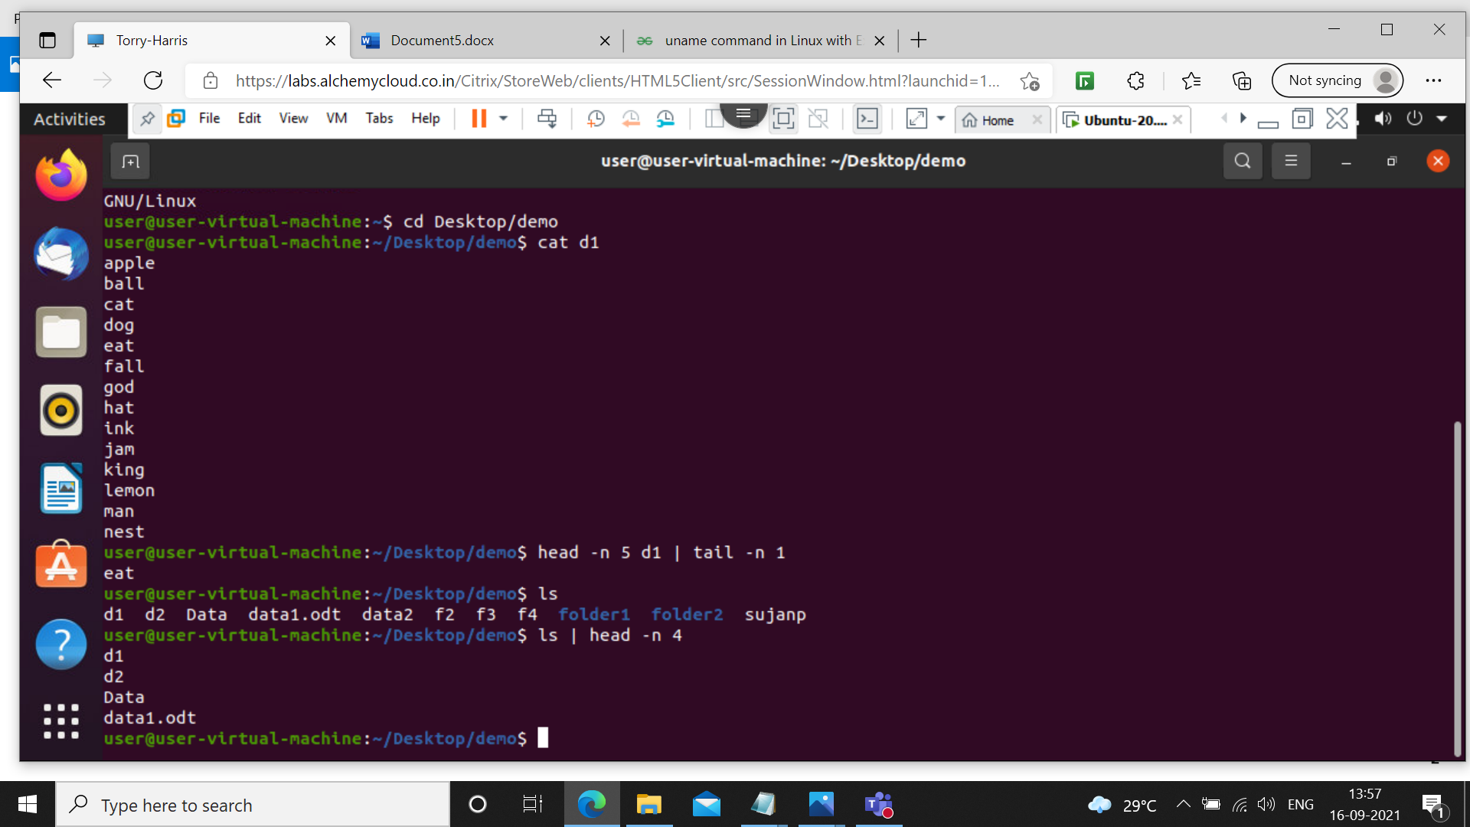

It will print only 4 files .ls is used for listing the files

**28 find . -type f**

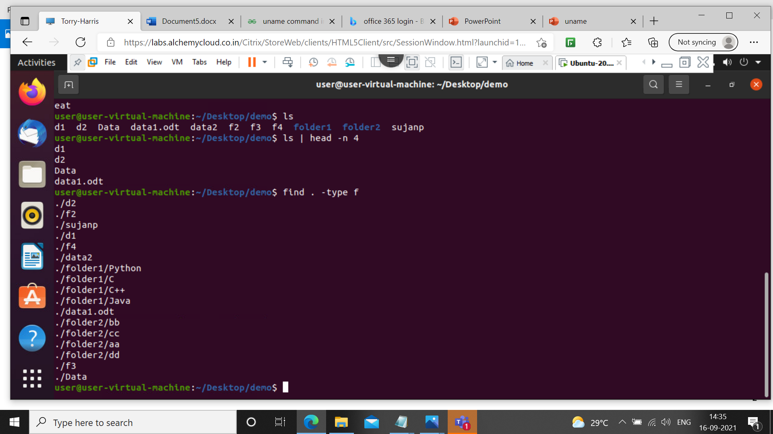

‘-type f’ specifies the input type is a file.find will find the files that are in the current directory.

**29 find –name d2**

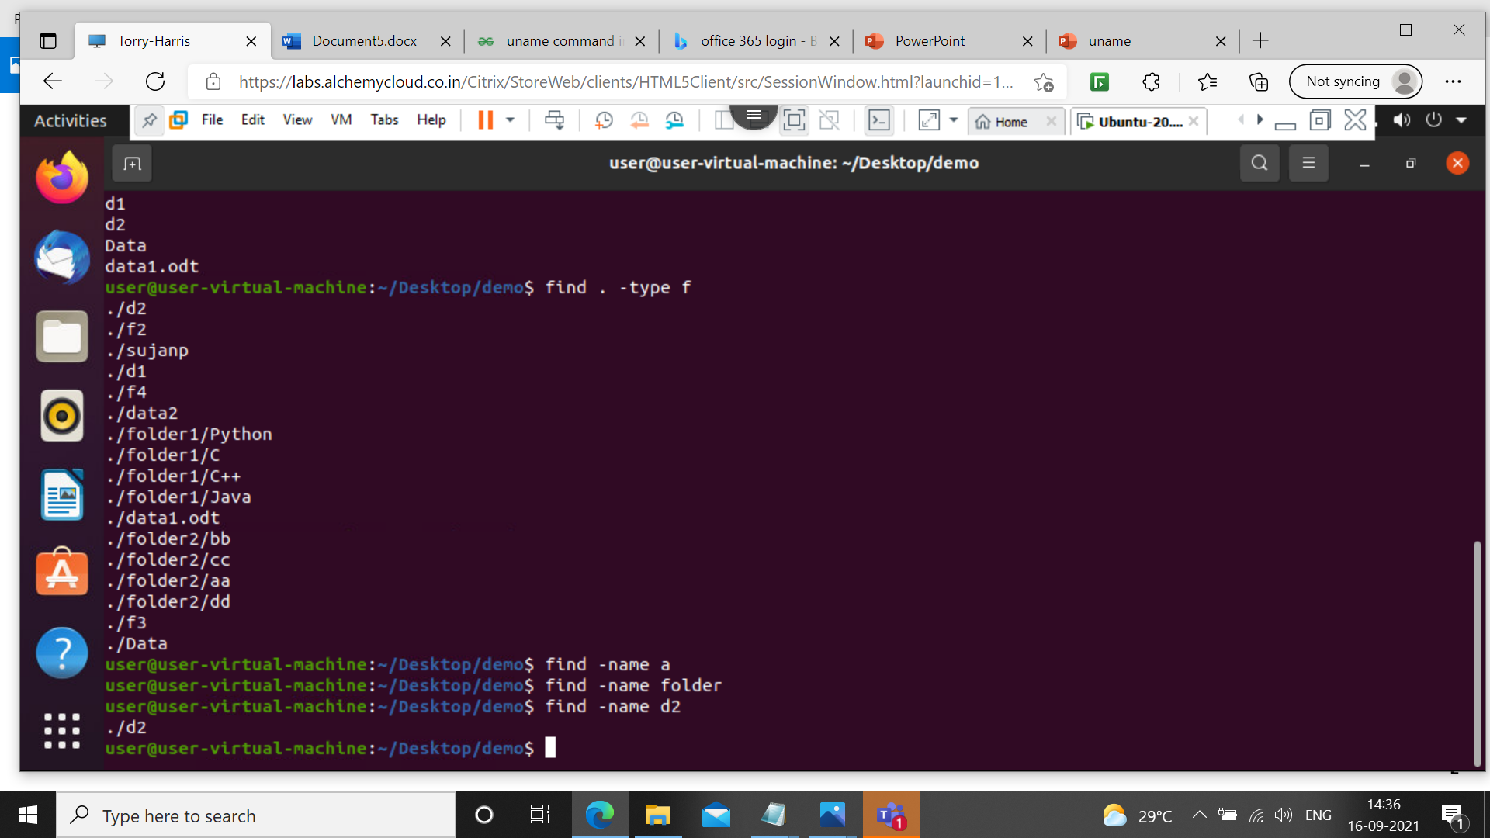Itwill find the particular file name